**Title of paper** (Times New Roman- 14pt- bold)

**Author Name[1], Author Name2, Author Name3**

1- Department of XXXX, Faculty of XXXX, University Name, City name, Iran. (Times New Roman- 10pt)

2- Department of XXXX, Faculty of XXXX, University Name, City name, Iran. (Times New Roman- 10pt)

3- Department of XXXX, Faculty of XXXX, University Name, City name, Iran. (Times New Roman- 10pt)

|  |  |
| --- | --- |
| **Article info** | **Abstract** |
| **Article type:**  Research Article  **Received:**  2023/01/10  **Accepted:**  2023/03/30  **pp:**  1- 16  **Keywords:**  Keywords,  Keywords,  Keywords,  (Times New Roman- 10pt- 3-5 words) | Abstract Abstract Abstract Abstract Abstract Abstract Abstract Abstract Abstract Abstract Abstract Abstract Abstract Abstract (Times New Roman- 10pt) 250-300 Words. |

|  |  |
| --- | --- |
| **QR Code** | **Citation:** Author Name. (2023).Title of paper. ***Journal of Urban Futurology***, 1(1), 1-20.  1691989224302 © The Author(s). **Publisher:** Islamic Azad University, Zahedan Branch.  DOI:  DOR: |

**1. INTRODUCTION** (12pt, Bold, Uppercase)

The introduction is the initial words of the author describing the problem; (citation: Fukugawa, N. (2022). Also, the introduction should state the reasons for the necessity of conducting the research and the purpose of conducting the research. Research questions and research objectives are stated in the introduction as well. The introduction section should not have any sub-sections. That is, the content of the statement of the problem, research questions, hypotheses, and the necessity of research should be included in the introduction without any sub-sections and with regular and correct paragraphing. Avoid any sub-titles in the introduction section. (Times New Roman-11pt-Justify)

**1-1. Background and theoretical foundations of research**

In the background of the research, the conducted research relevant to the subject of the manuscript (scientific articles and related printed reports) is reviewed and the results and achievements are briefly stated. In the background, the difference between the approach and method of the present manuscript and previous articles should be stated. In the theoretical foundations of the research, the definitions, concepts, and theoretical topics related to the subject, that have been used in the research, must be highlighted. The theoretical foundations of the research actually form the analytical support of the article and the hypothesis of the article relies on it. Theoretical foundations should not only include basic definitions and concepts that do not have much effect on the research method and its results. (Times New Roman-11pt-Justify)

**2. METHODOLOGY** (12pt, Bold, Uppercase)

The steps and method of conducting the research, which were mentioned in the abstract, should be explained in detail in this section. It is also necessary to specify the type of research, method, and tools of data collection. The research method should be illustrated precisely so that future researchers can use the same method to conduct similar research or complete the current research. It is important to avoid providing additional and unnecessary explanations that have an educational aspect in this section. Also, data measurement and analysis tools, indicators, and research variables should be mentioned. (Times New Roman-11pt-Justify)

**2-1. Study Area**

In this part, the study context will be introduced from political-geographical and demographic perspectives. (Times New Roman-11pt-Justify)

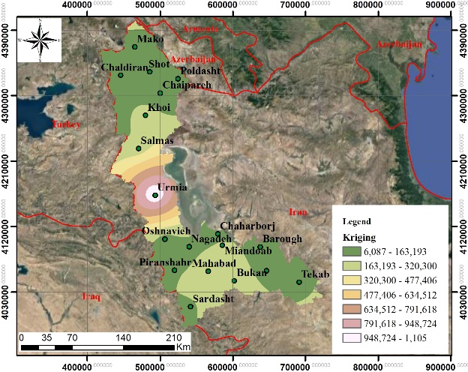

**Fig 1. Times New Roman-10pt Bold**

**3. RESULTS AND DISCUSSION** (12pt, Bold, Uppercase)

Research findings, answers to research questions, and evidence to accept or reject the hypothesis (if there is any) are presented in this section. Also, the results of the current research are compared with the results of similar studies, and the congruency and difference of findings of the current paper and previous ones are expressed in this section. (Times New Roman-11pt-Justify)

**Table 1. Times New Roman-10pt Bold**

|  |  |  |
| --- | --- | --- |
| **Times New Roman-10pt Bold** | **Times New Roman-10pt Bold** | **Times New Roman-10pt Bold** |
| Times New Roman-10pt | Times New Roman-10pt | Times New Roman-10pt |
| Times New Roman-10pt | Times New Roman-10pt | Times New Roman-10pt |
| Times New Roman-10pt | Times New Roman-10pt | Times New Roman-10pt |

(Source: Times New Roman-10pt)

**4. CONCLUSION** (12pt, Bold, Uppercase)

The conclusion should be the result of the discussion and findings of the current research; Therefore, it is necessary to compose the conclusion in a scientific, concise, and comprehensive manner and of course in an explanatory-analytical form. Immediately at the end of the conclusion, the author can present his suggestions based on the research results in the form of headlines. Do not give a separate sub-heading /sub-section to the recommendations; Rather, bring it connected to the conclusion. Avoid copying and pasting duplicate content, figures, and tables in the discussions and findings sections to the conclusion section. (Times New Roman-11pt-Justify)

**Funding**

There is no funding support.

**Authors’ Contribution**

Authors contributed equally to the conceptualization and writing of the article. All of the authors approved thecontent of the manuscript and agreed on all aspects of the work declaration of competing interest none.

**Conflict of Interest**

Authors declared no conflict of interest.

**Acknowledgments**

We are grateful to all the scientific consultants of this paper.

**REFERENCES** (12pt, Bold, Uppercase)

For citations in the reference list **(APA Style):** (Times New Roman-11pt-Justify)

**English books:**

Woods, M. (2005). Rural Geography. Sage Publication, London.

**Journals:**

**Articles by one author:**

Fukugawa, N. (2022). Effects of the quality of science on the initial public offering of university spinoffs: evidence from Japan. Scientometrics, 127(8), 4439-4455. <https://doi.org/10.1007/s11192-022-04433-3>

**Article by two authors:**

Haunschild, R., & Bornmann, L. (2022). Relevance of document types in the scores’ calculation of a specific field-normalized indicator: Are the scores strongly dependent on or nearly independent of the document type handling?. Scientometrics, 127(8), 4419-4438. <https://doi.org/10.1007/s11192-022-04446-y>

**Article by three authors:**

Vakkari, P., Chang, Y. W., & Järvelin, K. (2022). Largest contribution to LIS by external disciplines as measured by the characteristics of research articles. Scientometrics, 127(8), 4499-4522. <https://doi.org/10.1007/s11192-022-04452-0>

**Article by more than three authors:**

Wheeler, J., Pham, N. M., Arlitsch, K., & Shanks, J. D. (2022). Impact factions: assessing the citation impact of different types of open access repositories. Scientometrics, 127(8), 4977-5003. <https://doi.org/10.1007/s11192-022-04467-7>

1. **Corresponding author:** Author Name, **Email:** xxxxxxxxxxxxxx, **Tell:** +989000000000