|  |
| --- |
| **Public Service Marketing**  **Volume ?, Issue ? - Spring 2022 - Pages ?-?**  Homepage: <https://sanad.iau.ir/journal/jpsm> |

**Title [Times New Roman 16 Bold] Title Title Title Title Title Title [Befor Spacing: 30 pt & After Spacing: 18 pt]**

The name and organizational affiliation of the authors should not be included in this file **[Times 13 Bold]**

1. Affiliation of first author [Times New Roman 10]
2. Affiliation of second author
3. Affiliation of third author

|  |
| --- |
| **OPEN ACCESS**  **Article type:** Research Article |

**Abstract:** A single paragraph of about 200 words maximum. For research articles, abstracts should give a pertinent overview of the work. We strongly encourage authors to use the following style of structured abstracts, but without headings: (1) Background: Place the question addressed in a broad context and highlight the purpose of the study; (2) Methods: briefly describe the main methods or treatments applied; (3) Results: summarize the article’s main findings; (4) Conclusions: indicate the main conclusions or interpretations. The abstract should be an objective representation of the article and it must not contain results that are not presented and substantiated in the main text and should not exaggerate the main conclusions. [Font: Palatino Linotype 9]

**Keywords:** keyword 1; keyword 2; keyword 3 (List three to five pertinent keywords specific to the article yet reasonably common within the subject discipline.). [Font: Palatino Linotype 9] [Spacing: Before 12 pt]

**Extended Abstract**

**Introduction**

Introduction should not exceed 350 words and explains the Research problem/s addressing, Objective/s and literature review relating to the background of the research. [Font: Times New Roman 11][Text] [Text] [Text] [Text] [Text] [Text] [Text] [Text] [Text] [Text] [Text] [Text] [Text] [Text] [Text] [Text] [Text] [Text] [Text] [Text] [Text] [Text] [Text] [Text] [Text] [Text] [Text] [Text] [Text] [Text] [Text] [Text] [Text] [Text] [Text] [Text] [Text] [Text] [Text] [Text] [Text] [Text] [Text] [Text] [Text] [Text] [Text] [Text] [Text] [Text] [Text] [Text] [Text] [Text] [Text] [Text] [Text] [Text] [Text] [Text] [Text] [Text] [Text] [Text] [Text] [Text] [Text] [Text] [Text] [Text][Text] [Text] [Text] [Text] [Text] [Text] [Text] [Text] [Text] [Text] [Text] [Text] [Text] [Text] [Text] [Text] [Text] [Text] [Text] [Text] [Text] [Text] [Text] [Text] [Text] [Text] [Text] [Text] [Text] [Text] [Text] [Text] [Text] [Text] [Text] [Text] [Text] [Text] [Text] [Text] [Text] [Text] [Text] [Text] [Text] [Text] [Text] [Text] [Text] [Text] [Text] [Text] [Text] [Text] [Text] [Text] [Text] [Text] [Text] [Text] [Text] [Text] [Text] [Text] [Text] [Text] [Text] [Text] [Text] [Text] [Text] [Text] [Text] [Text] [Text] [Text] [Text] [Text] [Text] [Text] [Text] [Text] [Text] [Text] [Text] [Text] [Text] [Text] [Text] [Text] [Text] [Text] [Text] [Text] [Text] [Text] [Text] [Text] [Text] [Text] [Text] [Text] [Text] [Text] [Text] [Text] [Text] [Text] [Text] [Text] [Text] [Text] [Text] [Text] [Text] [Text] [Text] [Text].

An introduction of why to conduct the research, statement of the problem, the necessity and importance of the research and finally the statement of the goals should be given in this section.

**Case Study**

[Text] [Text] [Text] [Text] [Text] [Text] [Text] [Text] [Text] [Text] [Text] [Text] [Text] [Text] [Text] [Text] [Text] [Text] [Text] [Text] [Text] [Text] [Text] [Text] [Text] [Text] [Text] [Text] [Text] [Text] [Text] [Text] [Text] [Text] [Text] [Text] [Text] [Text] [Text] [Text].

If your research is a case study, introduce it briefly under this title in one paragraph.

**Theoretical Framework**

[Text] [Text] [Text] [Text] [Text] [Text] [Text] [Text] [Text] [Text] [Text] [Text] [Text] [Text] [Text] [Text] [Text] [Text] [Text] [Text] [Text] [Text] [Text] [Text] [Text] [Text] [Text] [Text] [Text] [Text] [Text] [Text] [Text] [Text] [Text] [Tex] [Text] [Text] [Text] [Text] [Text] [Text] [Text] [Text] [Text] [Text] [Text] [Text] [Text] [Text] [Text] [Text] [Text] [Text] [Text] [Text] [Text] [Text] [Text] [Text] [Text] [Text] [Text] [Text] [Text] [Text] [Text] [Text] [Text] [Text] [Text] [Text] [Text] [Text] [Text] [Text] [Text] [Text] [Text] [Text] [Text] [Text] [Text] [Text] [Text] [Text] [Text] [Text] [Text] [Text] [Text] [Text] [Text] [Text] [Text] [Text] [Text] [Text] [Text] [Text] [Text] [Text] [Text] [Text] [Text] [Text] [Text] [Text] [Text] [Text] [Text] [Text] [Text] [Text] [Text] [Text] [Text] [Text].

[Text] [Text] [Text] [Text] [Text] [Text] [Text] [Text] [Text] [Text] [Text] [Text] [Text] [Text] [Text] [Text] [Text] [Text] [Text] [Text] [Text] [Text] [Text] [Text] [Text] [Text] [Text] [Text] [Text] [Text] [Text] [Text] [Text] [Text] [Text] [Text] [Text] [Text] [Text] [Text] [Text] [Text] [Text] [Text] [Text] [Text] [Text] [Text] [Text] [Text] [Text] [Text] [Text] [Text] [Text] [Text] [Text] [Text] [Text] [Text] [Text] [Text] [Text] [Text] [Text] [Text] [Text] [Text] [Text] [Text] [Text] [Text] [Text] [Text] [Text] [Text] [Text] [Text] [Text] [Text] [Text] [Text] [Text] [Text] [Text] [Text] [Text] [Text] [Text] [Text] [Text] [Tex] [Text] [Text] [Text] [Text] [Text] [Text] [Text] [Text] [Text] [Text] [Text] [Text] [Text] [Text] [Text] [Text] [Text] [Text] [Text] [Text] [Text] [Text] [Text] [Text] [Text] [Text].

Present the conceptual framework of your research in a maximum of two paragraphs below this title. Referencing should be done and try to use the latest references.

**Methodology**

Methodology outlines the experimental procedure and data obtained in max. 200 words.[Text] [Text] [Text] [Text] [Text] [Text] [Text] [Text] [Text] [Text] [Text] [Text] [Text] [Text][Text] [Text] [Text] [Text] [Text] [Text] [Text] [Text] [Text] [Text] [Text] [Text] [Text] [Text][Text] [Text] [Text] [Text] [Text] [Text] [Text] [Text] [Text] [Text] [Text] [Text] [Text] [Text][Text] [Text] [Text] [Text] [Text] [Text] [Text] [Text] [Text] [Text] [Text] [Text] [Text] [Text]**.**

First, the method of conducting the research, then the society and the sample under study should be stated. Then the data collection tools, data analysis techniques should be briefly stated (in one paragraph).

**Discussion and Results**

Results and discussion section should not exceed 600 words and explains the data obtained. [Text] [Text] [Text] [Text] [Text] [Text] [Text] [Text] [Text] [Text] [Text] [Text] [Text] [Text] [Text] [Text] [Text] [Text] [Text] [Text] [Text] [Text] [Text] [Text] [Text] [Text] [Text] [Text] [Text] [Text] [Text] [Text] [Text] [Text] [Text] [Text] [Text] [Text] [Text] [Text] [Text] [Text] [Text] [Text] [Text] [Text] [Text] [Text] [Text] [Text] [Text] [Text] [Text] [Text] [Text] [Text] [Text] [Text] [Text] [Text] [Text] [Text] [Text] [Text] [Text] [Text] [Text] [Text] [Text] [Text].

The main findings of the research should be briefly stated and discussed in one to two paragraphs.

**Conclusion**

Conclusion should not exceed 100 words and explains the research outcome. [Text] [Text] [Text] [Text] [Text] [Text] [Text] [Text] [Text] [Text] [Text] [Text] [Text] [Text] [Text] [Text] [Text] [Text] [Text] [Text] [Text] [Text] [Text] [Text] [Text] [Text] [Text] [Text] [Text] [Text] [Text] [Text] [Text] [Text] [Text] [Text] [Text] [Text] [Text] [Text] [Text] [Text].

Summarize the results in one paragraph

**Contribution of authors**

All authors have participated in this research in equal proportion.

**Acknowledgments**

If it is necessary to thank an individual or an organization, it should be done under this title. This title is not required.

**Ethical approval**

Choose an item.

**Conflict of interest**

No conflicts of interest are declared by the authors.

**Introduction**

The introduction should briefly place the study in a broad context and highlight why it is important. It should define the purpose of the work and its significance. The current state of the research field should be carefully reviewed and key publications cited. Please highlight controversial and diverging hypotheses when necessary. Final-ly, briefly mention the main aim of the work and highlight the principal conclusions. As far as possible, please keep the introduction comprehensible to scientists outside your particular field of research.

**Theoretical foundations and research background**

The purpose of the research background should be to identify the knowledge gap of the previous research and refer to the following main subsections:

1. Theoretical background (existing theories, views, and approaches regarding the problem);
2. Empirical background (previous studies and their methodologies on the problem);
3. Conceptual model (if the research is quantitative and has a model).

**Research methodology**

This section should include (the method and type of research, data collection tools, data analysis techniques, definition of studied variables and their operational definition, statistical population, sample size, and sampling method).

**Research findings**

**Shapes**

Each figure, including a diagram, chart, map, etc., must have a number and description, none of these items have a separate number, but they are numbered in the middle of the Chinese below with bold Times New Roman font size 10 and numbered in order from 1.

Diagrams or figures should be included in the text and where they are referred to. It is mandatory to express the unit of quantities in the graphs. All diagrams must be referenced in the text of the article. In preparing the diagrams, pay attention that the size of the numbers, words, quantities and the curve guide (legend) is large enough so that they are completely clear and legible after being inserted in the article. Please note that if the diagram inside the article is in the form of an image (software output), it must be fully clear. It is better to put the main file of the diagrams in the text of the article. Place each diagram with a blank line space from the text before and after it. An example of a diagram is given below. (It should be noted that the graphs themselves, like the tables, should be placed in the center of the paper relative to the two sides of the paper.)

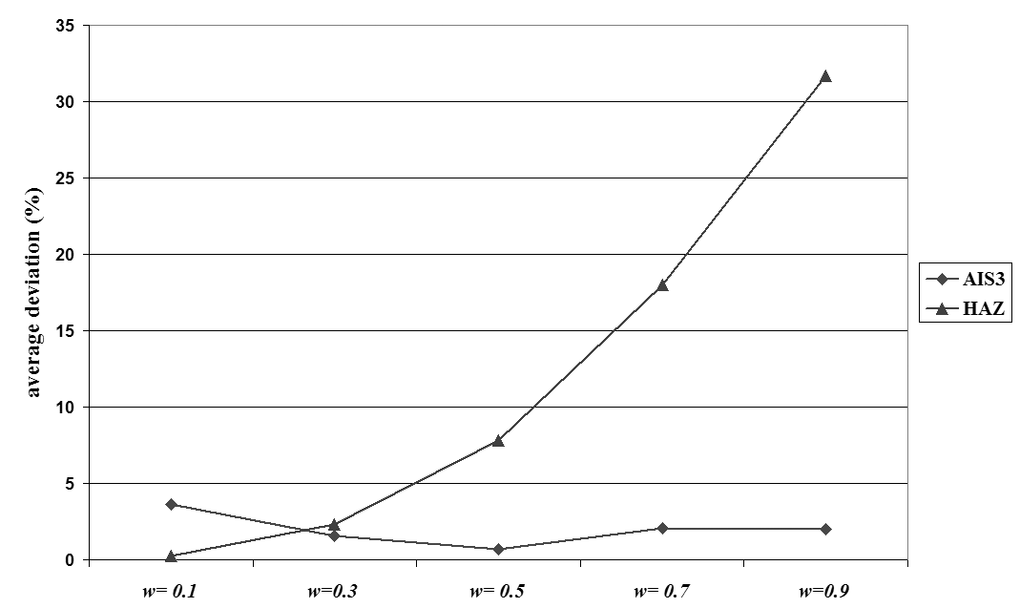

**Diagram 1. Diagram for example (reference)**

**Tables**

Each table must have a number and a title (explanation) which is numbered in the middle of the table with bold Times New Roman font size 10 and numbered sequentially from 1 and placed on top of the table. Tables should be inserted inside the text and after the place where they are mentioned.

It is mandatory to state the unit of quantities in the table. Each table should be placed with a blank line from the text before and after it, and if the tables are taken from a reference, the reference number should be given in the APA method at the end of the table title.

**Table 1. Table for example (reference)**

|  |  |  |
| --- | --- | --- |
| **Title 1** | **Title 2** | **Title 3** |
| entry 1 | data | data |
| entry 2 | data | data 1 |

**Mathematical formulas and relationships**

To show mathematical formulas and relationships, use a two-column table with invisible lines according to the example below. In the right column of this table, write the relationship number and in the left column the related relationship or formula. (It is mandatory to use Microsoft Equation in writing formulas).

This is example 1 of an equation:

|  |  |
| --- | --- |
| a = 1, | (1) |

the text following an equation need not be a new paragraph. Please punctuate equations as regular text.

This is example 2 of an equation:

|  |  |
| --- | --- |
| a = b + c + d + e + f + g + h + i + j + k + l + m + n + o + p + q + r + s + t | (2) |

the text following an equation need not be a new paragraph. Please punctuate equations as regular text.

## Mathematical Expressions and Symbols

Mathematical expressions and symbols should be inserted using **equation tool** of Microsoft word. References may be added for used equations to support its authenticity, e.g. this result has been analysed using Fourier series.

$f\left(x\right)=a_{0}+\sum_{n=1}^{∞}{\left(a_{n}\cos{\frac{nπx}{L}}+b_{n}\sin{\frac{nπx}{L}}\right)}$ (3)

**Discussion and conclusion**

discussion (comparing research findings with other research findings and theories); and conclusion (providing a summary of the results and practical and practical suggestions).

**Contribution of authors**

The contribution of all authors to the research should be specified. For example: All the authors have participated in this research in equal proportion. Or: This article is extracted from the master's thesis entitled "..." of the University of ..... with the guidance of Dr. and the advice of Dr. Or: The data collection of this research was done by ...., the data analysis was done by ...., and statistical corrections and conclusions were made by ....

**Acknowledgments**

If it is necessary to thank an individual or an organization, it should be done under this title. This title is not required.

**Conflict of interest**

Any conflict of interest must be reported. For example: no conflicts of interest are declared by the authors. Or: This research was carried out from the results of the research project implemented under project number.... using the research credits of the university...

It is possible that the results of a researcher's research will bring him economic benefit. If the author has a special position or condition that this position or condition has a relationship with the research and its results, this relationship should be fully clarified so that the audience can make more accurate decisions about the research and its results. If it is found that the authors and researchers had interests in the research and hid it, an ethical and possibly legal violation has occurred.

In general, the researcher has a conflict of interest in the following two situations and must report this conflict of interest:

* Communication with a person or organization that affects one of the goals or actions of the research.
* The presence of sources and financial sponsors who have played a role in each stage of design, collection, analysis, and interpretation of data and publication.

**References**

The in-text citation style should be the American Psychological Association (APA) citation style. Endnote software should preferably be used to manage references.

1. Aghajani, D. (2018). Provide management model for analysis of electricity generation from wind farms using WEB GIS system. *Quarterly Journal of Environmental Science and Technology*. <https://doi.org/10.22034/jest.2018.10782.1932>
2. Aghajani, H., Fattahi Moghaddam, M., Akbari, H., & Fattahi, R. (2015). Location of wind turbines based on environmental spatial assessment (Case study: Khorasan Razavi province). *Iran Energy*, *18*(1).
3. Alizadeh Goodarzi, H. (2011). *Development of methods for identifying, evaluating and prioritizing accident hotspots based on multi-criteria decision-making methods.* Semnan University].
4. Azari, A., Zarei, Z., & Hajibabaei, Z. (2016). Wind power measurement for sustainable energy development in Hamadan province. *Geography and Environmental Sustainability (Geographical Research Journal)*, *6*(19), 99-116.
5. Banani, F. (2020). *Location of municipal solid waste landfill by fuzzy logic and hierarchical analysis (Case study: Pardis New City).* Payame Noor University of Tehran Province]. Payame Noor Center of East Tehran.
6. Zakeri Fard, R., Abdi, H., & Khonakdari, T. (2011). Feasibility Study of Construction of a 10 MWWind Power Plant in MoravehTappeh. *Iranian Journal of Energy*, *14*(1), 55-77. <http://necjournals.ir/article-1-207-fa.html>