Dr. OMRAN MORADLOU  Associate Professor  Department of Chemistry,  Faculty of Physics and Chemistry  Alzahra University,  Tehran, Iran  Tel. & Fax: + 98-21-88613937  Office Tel.: +98-21-85692613  E-mail: moradlou@alzahra.ac.ir  Nano-GEM research group  After receiving PhD degree in Analytical Chemistry from Shiraz University in 2009, Dr. Omran Moradlou joined Sharif University of Technology (Physics Department, NEST research group) as postdoctoral research fellow for two years.  In PhD program, he developed new ionic liquid-based electrodes for the determination and electrochemical study of biologically important compounds.  In 2011, Dr. Omran Moradlou joined Alzahra University as faculty member and started researches on energy and environmental concepts.  The main research interests of Dr. Omran Moradlou is the renewable and green sources of energy including hydrogen energy from photoelectrochemical systems and photovoltaic cells, as well as energy storage devices including supercapacitors.  In 2015, he has established a research group called Nano-GEM in Alzahra University. Nano-GEM is a research group represents the group’s activity on the multidisciplinary fields namely Green Energy Nanomaterials for the energy conversion and storage devices such as solar cells, photoelectrochemical cells and supercapacitors. He has published several high impact articles on energy storage and production systems since 2011. | 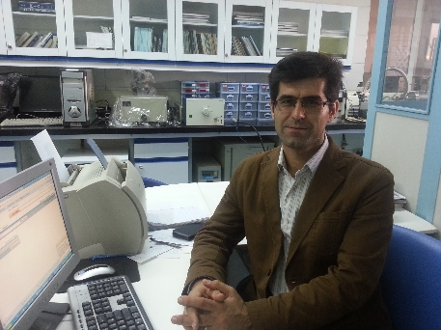
2009- 2011 Postdoctoral Fellow, Photoelectrochemistry
Department of Physics, Sharif University of Technology, Tehran, Iran

2003 - 2009 PhD , Analytical Chemistry: Electrochemistry
Chemistry Department, Shiraz University, Shiraz, Iran
Dissertation: Electrochemistry and electrocatalysis of some biologically important compounds on carbon ionic liquid electrode (CILE), mediator modified and gold nanoparticle-modified CILE
2000 - 2003 M.Sc. , Analytical Chemistry: Chemometrics
Chemistry Department, Shiraz University, Shiraz, Iran
Dissertation: Application of chemometric methods in simultaneous determination of some anions & pharmaceuticals
1995 - 1999 B.Sc. , Applied Chemistry
Chemistry Department, Sharif University of Technology, Tehran, Iran
B.Sc. Project: Synthesis of "Nitrons" and their kinetic studies in addition reactions

Address : Department of Chemistry, Alzahra University, Vanak Ave., Tehran, Iran.
Tel : +9821-85692613
Fax : +9821-88613937
E-mail: moradlou@alzahra.ac.ir

