ORIGINAL RESEARCH PAPER

Article title

Author1: Professor in Department of Human Geography and Spatial Planning, University, Tehran, Iran.
Author2: Ph.D. in Human Geography and Spatial Planning, University, Tehran, Iran.
Citation: Anabestani, A. A., & Ghorbani, A. (2023). Analysis of the Effect of Development Capital on Changes in the Level of Sustainable Development of Rural Settlements (Case study: Bojnurd County). Journal of Land Use and Sustainable Development, Vol 13, No 51, PP: 93-114.
DOI: 10.30495/JZPM.2021.26592.3787
DOR:
COPYRIGHTS
©2023 The author(s). This is an open access article distributed under the terms of the Creative Commons Attribution (CC BY 4.0), which permits unrestricted use, distribution, and reproduction in any medium, as long as the original authors and source are cited. No permission is required from the authors or the publishers.



Abstract | A R T I C L E I N F O
In the last two decades, the concept of social capital has been emphasized due to its relationship with basic social components including awareness, participation, trust, cohesion, and social network for sustainable development of communities, especially rural communities. In addition to social capital, we are also dealing with physical, economic, human, natural, and institutional, which are also interrelated. The purpose of this study is to evaluate the effectiveness of development capital in the sustainable development of rural settlements and its spatial analysis in Bojnurd. The present research is descriptive-analytical and its type is fundamental in terms of purpose. Documentary and field methods have been used to collect information. The sample population is 22 villages with more than 20 households in Bojnurd city and from a total of 4849 households living in the sample rural areas, with Cochran's formula, the sample size of 298 households was calculated and these individuals were selected by random sampling method. To test the conceptual model of the research and to investigate the effect of development capital on the sustainable development of rural settlements, the partial least squares technique and Smart PLS software were used. According to the results, the coefficients of t between the main variables of the study are more than 2.58, i.e. the relationship is significant and indirect; Thus, types of development capital have a positive and significant effect on the sustainable development of rural settlements and social capital with a coefficient of 0.443 has the most direct impact on sustainable rural development, but in general, economic capital with a coefficient of 0.918 has the highest and natural capital with a coefficient of -0.147 Has the least impact on the sustainable development of rural settlements. And the independent variable predicts %93.1 of the variance of the sustainable rural development variable. | Received:2025/01/20  Accepted:2025/03/20  PP: 1-18  Use your device to scan and read the article online    Keywords: Development Capitals, Social Capital, Sustainable Rural Development, Structural Equations, Bojnurd.

INTRODUCTION
Improper and unprincipled exploitation and in other cases, Lack of proper efficiency in exploiting the available resources in the villages, it has caused livelihood problems and created instabilities in the environment as the main source of rural livelihood (Day, 2012). Therefore, it is necessary in proportion to the changes in production methods and creation of competitive markets, make changes in rural livelihoods so that villages can be developed and sustainable in terms of livelihood. Achieving a sustainable rural livelihood is not possible without considering the livelihood assets and capital in the villages. The approach to sustainable livelihoods of resources as assets or capital includes six main dimensions Which includes human assets, physical assets, financial assets, social assets, institutional assets and natural assets. Accordingly, development capital is considered as a very important theoretical tool to analyze the role of variables of sustainable rural development. It is necessary to know the current status of these capitals or assets and their components and their place in the development of different rural communities, in order to Proper and fit planning, based on the temporal and spatial characteristics of each of these communities, for the development of rural settlements(Ching and Winkel, 2018; Dobry et al., 2000)

Literature Review
For instance, the shear wave velocity at shallow depth is key input parameter in estimating ground motion. The Vs₃₀ values of sites can be determined by multichannel surface-wave analysis (MASW) using active sources such as a sledgehammer (Park et al., 2007).

The Area under Study
Alternatively, the less invasive spatial auto-correlation (SPAC) method can be used to determine (Fig. 1).

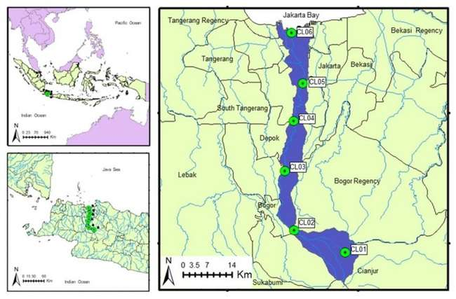
sample map

Figure 1. The Location of the Area under Study in the Map of Iran
Methodology
As it is clear from the title of the article, the study area in the present study is Bojnurd county in North Khorasan province. The statistical population in this study includes rural settlements in Bojnurd county, according to the 2016 census, there are 150 inhabited villages with a population of 105,378, of which 135 villages have a population of over 20 households (with a total population of 104,605).

Results and Discussion
The hydraulic conditions of WDNs are generally evaluated by using demand-driven modeling (DDM) models as a demand function in normal operational conditions and additional pressure-driven modeling (PDM) implementations that have better responded to WDNs (WDN) analysis in operating conditions. Water distribution calculations were investigated by an under-pressure model, as it provided a better description of the system’s conditions than the classical model formulas in the event of a pipe failure.
Table 1: Suitability classes of factors for dam site
Factors | Categories | Ranking | Suitability
Slope | ≤ 3.1 | 4 | High Suitable
 | 3.1- 7.9 | 3 | Suitable
 | 7.9 – 12.9 | 2 | Low suitable
 | 12.9- 19.7 | 1 | Not Suitable
Distance from Roads | ≤ 1 000 m | 4 | High Suitable
 | 1 000 m – 2 000 m | 3 | Suitable
 | 2 000 m – 3 000 m | 2 | Low suitable
 | > 3 000 m | 1 | Not Suitable
Distance from Settlements and markets | < 10 km | 4 | High Suitable
 | 5-10 km | 3 | Suitable
 | 1-5 km | 2 | Low suitable
 | > 1km | 1 | Not Suitable
Soil Type | Masooka rock land | 4 | High Suitable
 | Rough mountainous land | 3 | Suitable
 | Pirsbak | 2 | Low suitable
 | Kamala complex | 1 | Not Suitable
Distance from Agricultural fields | > 500 m | 4 | High Suitable
 | 400 m – 500 m | 3 | Suitable
 | 200 m – 400 m | 2 | Low suitable
 | > 200 m | 1 | Not Suitable

Conclusion
Development and facilitation of sustainable rural development requires knowledge of its components and effective indicators. Theoretically, by relying on two main theoretical approaches in rural studies, the necessary conditions for sustainable development can be provided. These approaches include empowerment and capacity building which can enhance the potential and actual capabilities in rural areas for use in sustainable livelihood development.

Ethical considerations:
Following the principles of research ethics: In the present study, informed consent forms were completed by all subjects.
Sponsor:
Conflict of interest: According to the authors, this article was free of any conflict of interest.

References
Jena, R.; Pradhan, B.; Beydoun, G., (2020). Earthquake vulnerability assessment in Northern Sumatra province by using a multi-criteria decision-making model. Int. J. Disaster Risk Reduct., 46(2020): 101518.
https://www.sciencedirect.com/science/article/abs/pii/S2212420919312208?via%3Dihub
Arai, H.; Tokimatsu, K., (2004). S-wave velocity profiling by inversion of microtremor H/V spectrum. Bull. Seismol. Soc. Am., 94(1), 53-63.
https://pubs.geoscienceworld.org/ssa/bssa/article-abstract/94/1/53/103019/S-Wave-Velocity-Profiling-by-Inversion-of?redirectedFrom=fulltext
Zhang, C. X., Fong, L. H. N., Li, S., & Ly, T. P. (2019). National identity and cultural festivals in postcolonial destinations. Tourism Management, 2(73), 94-104. https://doi.org/10.1016/j.tourman.2019.01.013

Corresponding author: ………….............................. Email: ……………………………………………….., Tel: +989……………………..

