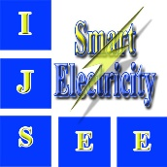

**International Journal of Smart Electrical Engineering (IJSEE)**

***Conflicts of Interest Statement***

Manuscript Title:

Manuscript ID:

The authors whose names are listed immediately below certify that they have no afflictions with or involvement in any organization or entity with any financial interest(such as honoraria; educational grants; participation in speakers’ bureaus; membership, employment, consultancies, stock ownership, or other equity interest; and expert testimony or patent-licensing arrangements), or non-financial interest (such as personal or professional relationships, afflictions, knowledge or beliefs) in the subject matter or materials discussed in this manuscript.

This statement is signed by all the authors to indicate agreement that the above information is true and correct.

**Author's name Author's signature Date**